# Guide to Assigning Scores for Missing Domains on ACCESS for ELLs Tests

# for English Learners with Disabilities

Prepared by Kathleen Flanagan and Dan Wiener

April 2020; revised November 2021

## Executive Summary

When taking the ACCESS for ELLs test, English learners with disabilities are sometimes unable to participate in the full suite of four domain tests (Listening, Reading, Speaking, and Writing) due to the lack of an available accommodation. In these circumstances, **the absence of one or more domain scores will prevent the student from receiving an overall composite score**, which is needed to determine a student’s proficiency in order to eventually exit EL status and can impede the evaluation of the student’s progress toward proficiency.

This document describes the process that will be used by the Massachusetts Department of Elementary and Secondary Education to apply up to two **assigned scores** for domains on the ACCESS for ELLs test taken by an eligible English learner who was unable to participate due to the lack of an available accommodation. The criteria for determining which students are eligible to receive an assigned score are described below.

Assigned scores will be included in the calculation of the overall score in the school and district DropBox files but will **not** be included on Individual Student Reports (ISRs), also known as Parent/Guardian Reports, because of a high probability of misinterpretation of the assigned score by parents. Assigned scores will not be included in aggregated score reports (i.e., school- or district-level results) nor will they be included in accountability determinations.

## Rationale

Assigned scores will enable an eligible student to receive an **overall proficiency score** on the ACCESS for ELLs test. A student would need an overall proficiency score in order to 1) receive a **progress indicator** showing whether the student’s growth-to-proficiency target was achieved for the current school year (beginning with 2020–2021 results); 2) receive a **growth-to-proficiency target** for the following school year; and 3) be **eligible to exit English learner (EL) status** once the student has earned an overall proficiency score of at least Level 4.2.

## Eligible Students

The Department will assign a score for up to two missing ACCESS domainsfor an EL student with a disability when **all four** of the following criteria are met:

* The EL student has an IEP or 504 plan that lists the accommodation(s) used by the student.
* The EL student’s disability status and nature of disability have been documented in the Student Information Management System (SIMS).
* The untested domain test was designated with a “Do Not Score” code of “SPD” on the ACCESS test.
* The EL student did not participate in a domain test because they met one of the test exemption criteria shown in Table 1.

Table 1 indicates eligibility for an exemption in a test domain based on an unavailable accommodation.

**Table 1:** Test exemption criteria for ACCESS domain tests

|  |  |
| --- | --- |
| **Test Exemption Criteria** | **Explanation** |
| The student’s primary disability is reported as “Sensory: Hard of Hearing or Deaf.” | The student is not requiredto take the Listening and Speaking tests, because they are unable to listen to and/or respond verbally to test items. The student must take the Reading and Writing tests. |
| The student’s primary disability is reported as “Sensory: Vision Impairment or Blind.” | The student is not required to take the Listening and Speaking tests, due to the use of graphics and other visual stimuli on those domain tests. The student must take the Reading and Writing tests either in Braille, large-print, or standard format. |
| The student meets the criteria to receive the [ELA read-aloud “special access” accommodation](http://www.doe.mass.edu/mcas/accessibility/manual.docx) on the MCAS ELA test and this is already listed in the student’s IEP or 504 plan. | The student is not required to take the Reading test, but must take the Listening, Speaking, and Writing tests. (Note: The school *may*, at its discretion, administer the Reading test to the student without the accommodation.) |
| The student is nonverbal (or selectively mute) and is therefore unable to participate in the Speaking test. | The student is not required to take the Speaking test but must take the Listening, Reading, and Writing tests. |

Table 2 shows the number and percentage of EL students in 2017, 2018, and 2019 who would have been eligible to receive a score assignment due to their test status, IEP/504 status, and the accommodations listed in their IEP/504 plan. The percentage of students who would have qualified for a score assignment (0.3% in 2018 and 0.2% in 2019) is small when compared with the number of students who took ACCESS tests in all four domains.

**Table 2:** Number and percentage of students who would have been eligible to receive a score assignment between 2017 and 2019

|  |  |  |  |  |  |
| --- | --- | --- | --- | --- | --- |
| **Year** | **Students with Missing Domain Scores** | | | **Total Students Tested** | **% of Students with Missing Scores** |
| **1 Missing Score** | **2 Missing Scores** | **Subtotal** |
| 2017 | 475 | 68 | 543 | 84,558 | 0.64% |
| 2018 | 220 | 83 | 303 | 88,577 | 0.34% |
| 2019 | 100 | 67 | 167 | 95,418 | 0.18% |

Between 2014 and 2019, the number and percentage of students who would have met eligibility requirements to receive an assigned score decreased, from 0.9% of tested students in 2014 to 0.2% in 2019. However, this decrease may have been the result of test administrators incorrectly coding the students’ non-participation on their tests (i.e., as something other than “SPD”).

As shown in Table A1 (Appendix), among students eligible for a score assignment in 2018 and 2019, the majority of students missing one score were missing the Reading domain test score (over 90% of those eligible). The majority of students missing two scores were missing both Listening and Speaking test scores in both years.

## Methods Studied for Calculating an Assigned Score

Assigned scores may be calculated using a variety of methods, and applied and integrated with other tested domain scores to obtain an overall score using the ACCESS for ELLs “weighting” formula in the four domains (Overall Score = Reading 35% + Writing 35% + Listening 15% + Speaking 15%).

The two methods described below were considered for adoption by the Department from among four methods proposed by WIDA researchers.

* **Method A: “Average (mean) domain score method,”** which substitutes the missing domain score(s) with an average of the scores in the other domains.
* **Method B: “Z-score method,”** which substitutes the missing domain score(s) with an average “Z-score” in the domain(s). (This method involves placing the student’s test scores on a normal distribution curve based on the scores of other MA students on that test, and then basing the student’s missing score on the scores of comparable students.)

Ultimately, the Department selected the **Average (mean) domain score method (Method A)** for assigning ACCESS for ELLs domain scores for eligible students.One challenge with either method is that students with missing domain scores may also be missing Literacy (Reading + Writing) and Oral Language (Listening + Speaking) composite scores as a result. When a composite score relies on assigned rather than actual scores, the results may not be considered a valid interpretation of the student’s actual abilities. (For example, can we infer that a student is proficient in Literacy if their Reading test score was assigned?).

**For the purpose of determining English proficiency for a student with an assigned score, the Department will consider a student with an assigned score to be proficient when their overall ACCESS proficiency level is 4.2 or higher.** (This criterion bypasses the existing requirement that a student have a composite Literacy score of Level 3.9.) (Note also that English proficiency must be confirmed using additional indicators described in the Department’s publication entitled [*Guidance on Placement, Progress Monitoring and Reclassification Procedures of English Learners, January 2019*](http://www.doe.mass.edu/ele/guidance/general/placement.docx)*.*) Exited students are monitored for four years to determine their progress in the general curriculum and whether they were exited appropriately or require additional language instruction.

Below is a description and comparison of both methods studied by the Department.

**Method A: Average (Mean) Domain Score**

This method substitutes the missing score(s) with an **average of the student’s other tested domain scores**, using the following steps:

1. Calculate an average scaled score by taking a simple mean of the student’s available scaled scores. The mean scaled score is then substituted for up to two missing domain scores.
2. Estimate an overall scaled score using the standard ACCESS weighting for each domain (i.e., Reading 35% + Writing 35% + Listening 15% + Speaking 15%) based on all of the student’s domain scores, including assigned scores.
3. Generate and apply a lookup table of overall ACCESS scaled scores to ACCESS proficiency levels.

A challenge with this method is the assumption that the domain scores are highly and positively correlated and thus interchangeable, which may not be true. For example, this method might overstate a student’s missing Reading score by substituting an average of the Listening, Speaking, and Writing scores, which may be higher than the Reading score would have been.

***Results of Using Method A***

Using actual student data from the 2018 and 2019 ACCESS tests, when assigned scores were calculated and applied to missing scores for eligible students, 24 students (7.9% of eligible students in 2018) and 7 students (4.2% of eligible students in 2019), mostly in grades 3–5, reached the state-defined criteria for proficiency. In the absence of using assigned scores during those years, the students would not have received an overall score and would not have had an opportunity to be considered to exit “English learner” status.

**Method B: Z-Score**

This method uses “Z-scores” to assign scores to missing domains for eligible students. Z-scores are derived from all other students who took the ACCESS tests and who scored similarly to the eligible student in the other tested domains. The Z-score method replaces the student’s missing score with the mean score of the larger group.

Z-scores are shown in standardized units, with a mean of 0 and a standard deviation of 1, and have a known distribution across the z-score scale, including more volume around the mean and a large drop-off at the tails of the distribution, as shown in Figure 1.

**Figure 1:** Z-Score Depiction

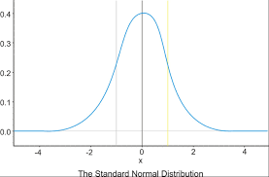

***Z-Score Formula***

A Z-score for each domain is calculated by subtracting the student’s domain score from the mean score for that grade and year, and then dividing by the standard deviation for that grade and year.

Z-Score = (Mean Domain Score minus Student’s Domain Score) ÷ Standard Deviation of the Domain

In using the Z-score method, WIDA recommends the following steps:

1. Calculate a Z-score for each domain score.
2. Calculate an overall Z-score using the ACCESS weighting formula.
3. Substitute missing domain scores with the overall Z-score for each student.
4. Generate and apply a lookup table of overall Z-scores to ACCESS scaled scores.

Generate and apply a lookup table of Z-scores to ACCESS proficiency levels. (Note: Our application of this method generated a single lookup table of overall Z-scores to their equivalent ACCESS proficiency levels, bypassing the step of identifying scaled scores.)

***Results of Using Method B***

The Z-score method was modeled using actual student data from the 2018 and 2019 ACCESS tests. When assigned scores were calculated using the Z-score method and applied to missing scores for eligible students, 20 students (6.6% of assigned scores in 2018) and 5 students (3% of assigned scores in 2019), also mostly in grades 3-5, would have scored proficient.

**Comparison of Methods A and B**

Both methods identified a core group of students eligible to receive an assigned score. Method A (the Average [Mean] Domain Score method) identified four more students who would have attained proficiency in 2018 and 2 more students in 2019, compared to Method B (the Z-Score method).

Table 3 shows a comparison of eligible students who met and did not meet exit criteria by attaining English proficiency based on assigned scores generated by Method A and Method B. Table 4 shows eligible students who met exit criteria based on assigned scores in each grade.

**Table 3:** Number and Percentage of students in 2018 and 2019 identified by Methods A and B as eligible for a score assignment, and percent who would have met criteria to exit EL status.

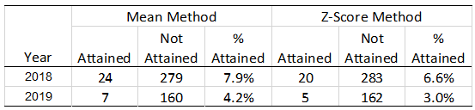

**Table 4:** Number of students identified as meeting exit criteria based on an assigned score,

by method, year, and grade

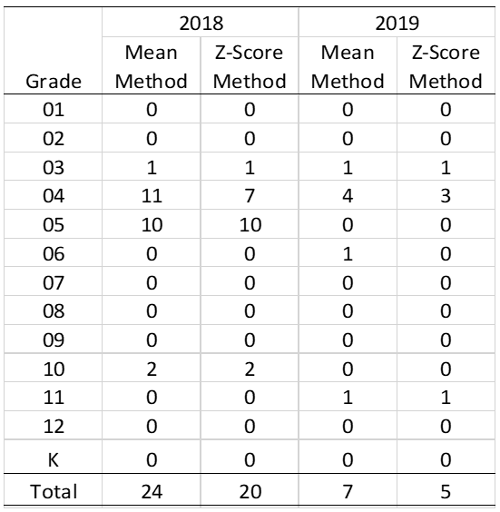

Additional information on the quality and accuracy of each method is presented in Appendix A, Tables A2 and A3. Table A2 presents correlations between actual ACCESS proficiency levels and the estimated ACCESS proficiency levels for each method. The correlations of both Methods A and B were high, ranging from .988 to .995, with correlations slightly higher for Method B, the Z-score method.

Although Method B showed slightly higher correlation with the actual ACCESS proficiency levels, in our study Method A was slightly more sensitive in identifying students who meet exit criteria. Both methods demonstrated similar levels of accuracy. Table A4 presents statistics on how well each method captured the actual proficiency classifications, with Method A slightly more accurate in that regard.

Given the ease of administering the Average (Mean) Domain Score method and its accuracy and sensitivity in identifying student proficiency, the Department elected to use Method A for the purpose of assigning missing ACCESS domain test scores.

## Summary

The Department studied two possible methods for assigning missing ACCESS for ELLs domain scores. Both methods identified students eligible to receive up to two assigned scores. Assigned scores make it possible for an eligible student to receive an overall proficiency level which is needed for a student to be considered to exit EL status. The ability to calculate overall proficiency levels also enables the Department to include a greater number of EL students in individual progress-toward-proficiency determinations from one year to the next.

The number of students eligible for score assignment is relatively small—only 303 students in 2018 and 167 students in 2019, out of about 95,000 tested students. Of those eligible for score assignment, fewer than 10 percent would have received an overall proficiency level of 4.2 or higher using either method, with slightly more students identified for proficiency using the Average (Mean) Domain Score method. The Department has determined that it will use Method A, the Average (Mean) Domain Score method, to calculate scores in untested domains for eligible students beginning in 2019−2020 because of its ease of use, its sensitivity in identifying proficiency, and the simplicity of explaining this method to educators and parents. The Department will not provide assigned scores in individual domains, but rather an assigned overall composite score only, which may be used to determine exit eligibility and instructional placement of students.

REFERENCES

Porter, T., Cook, H. G., & Sahakyan N. (2019). *Less than four domains: Creating an overall composite score as an indicator of English language proficiency for English learners with 504 or individualized education plans* (WCER Working Paper No. 2019-3). Retrieved from University of Wisconsin–Madison, Wisconsin Center for Education Research website: <http://www.wcer.wisc.edu/publications/working-papers>

Appendix A: Additional Data Tables

**Table A1:** Percent of Eligible Students Missing Domain Scores by Domain and Year

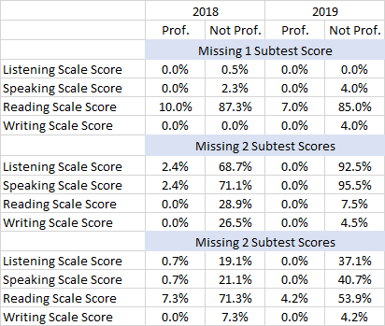

**Table A2:** Correlations between Actual and Assigned ACCESS Levels

|  |  |  |
| --- | --- | --- |
| **Method for Assigning Levels** | **2018** | **2019** |
| Average (Mean) Method | 0.988 | 0.990 |
| Z-Score Method | 0.933 | 0.995 |

**Table A3:** Contingency Table Statistics by Score Assignment Method

Various Statistics for the Average (Mean) and Z-Score Methods

Positive Predicted Value: % Attainment Captured (should be ~ 0.19)

Negative Predicted Value: % Not Attained Captured (should be ~ 0.81)

Sensitivity: Proportion of Attained Students Correctly Captured (should be ~ 1)

Specificity: Proportion of Not Attained Students Correctly Captured (should be ~ 1)

Accuracy: Proportion of Overall Accuracy (should be ~ 1)